VWC client software setup steps of the IP streams
- Click【Setup】-【Decoder】。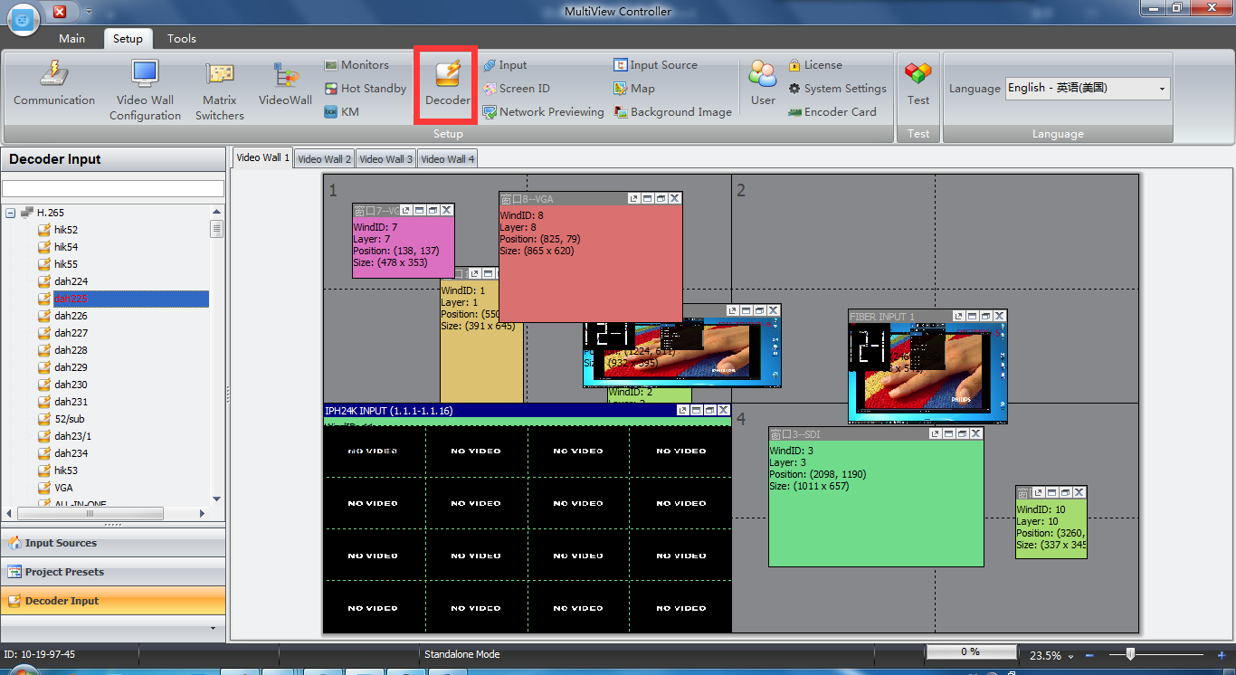
- Click Add-Show Advanced Fields.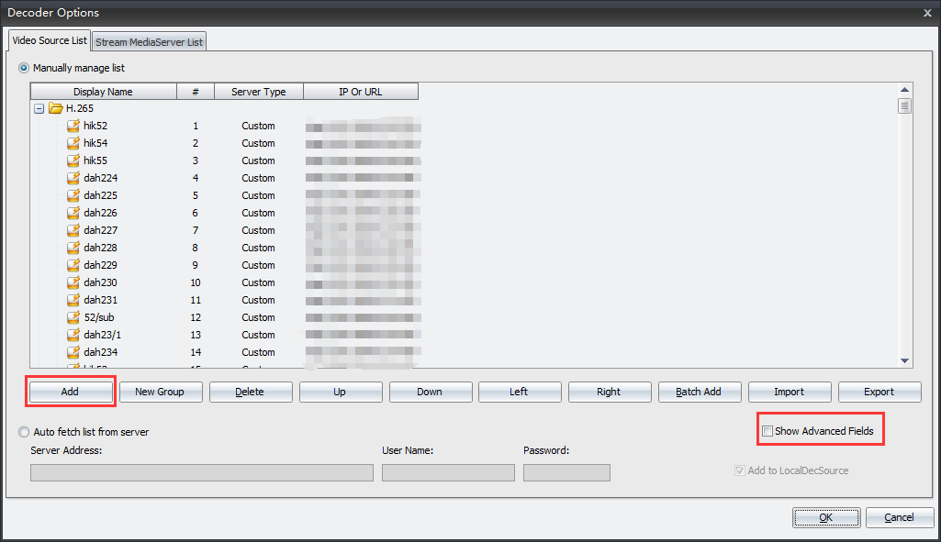
- Setup Display Name,IP Or URL,Port,Quality,User Name,Password,and so on,then click OK button.
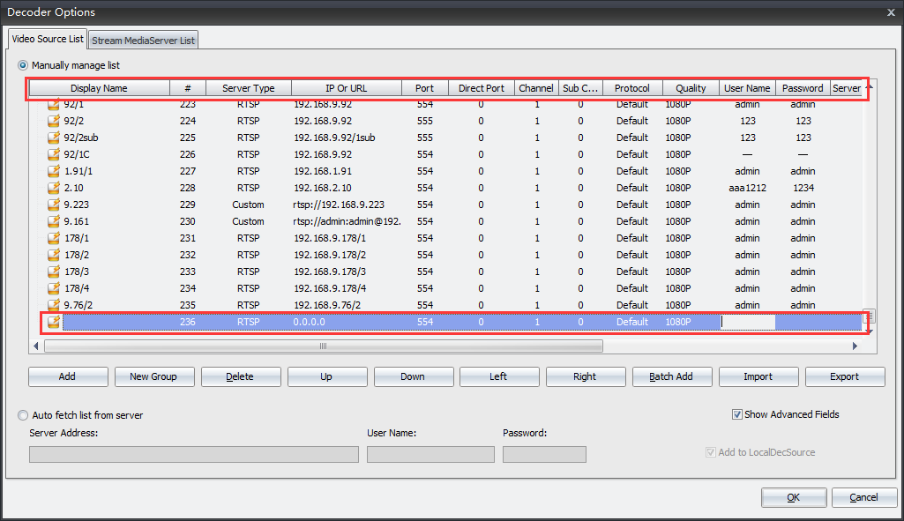
- Then the camera we just added is shown on the Decoder Input list,
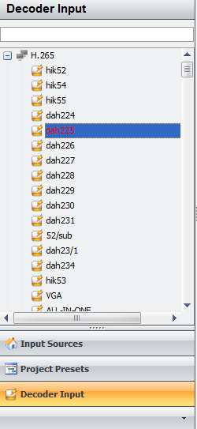
- Open a video window using the corresponding decode card from the Input Source.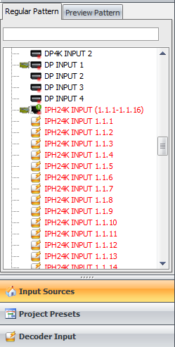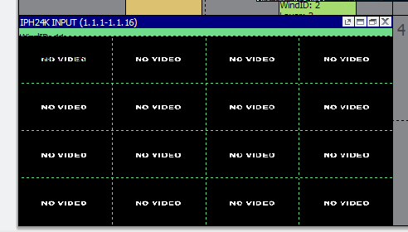
- Click sub channel of the Decode Input,then double click the camera we just added in the Decoder Input list.Or select the camera we just added in the Decoder Input list,and drag to the sub channel 1 of the video window.
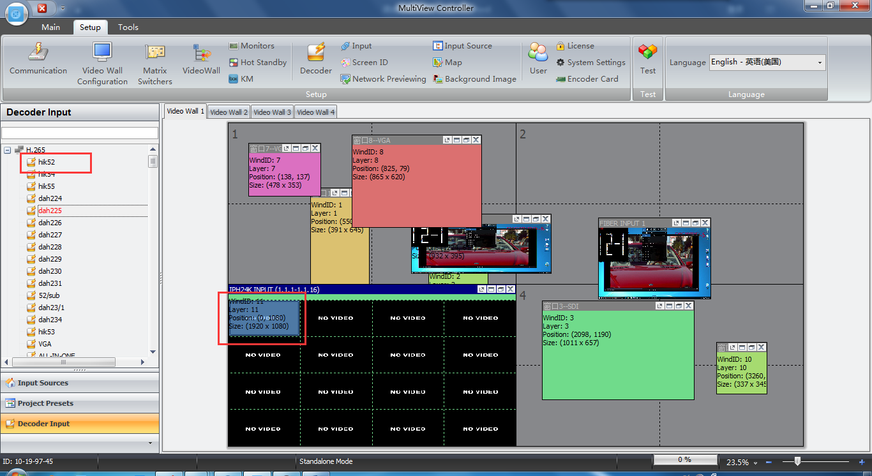
END

